Segment Joining Two Points in Space
# Source: AI Source: Provided by: [Data Path: Persons Table -> ID Column: 1, Name_En Column: Motasem Essam] -> From: [ChatGPT] on [7/25/2026]
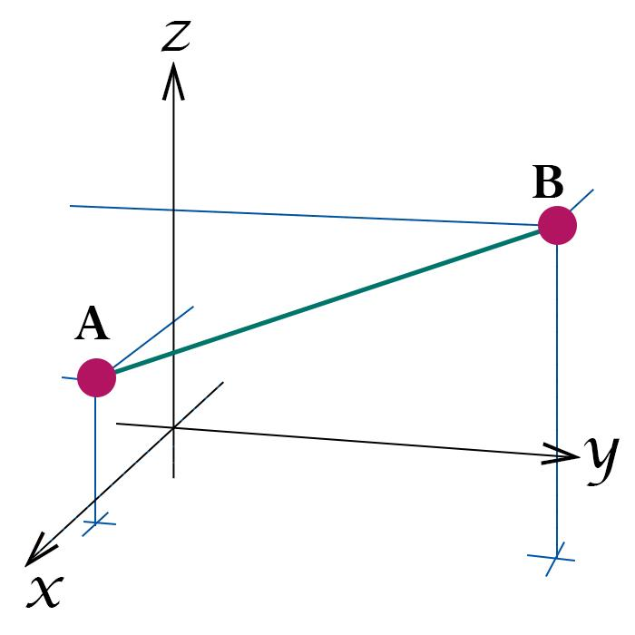
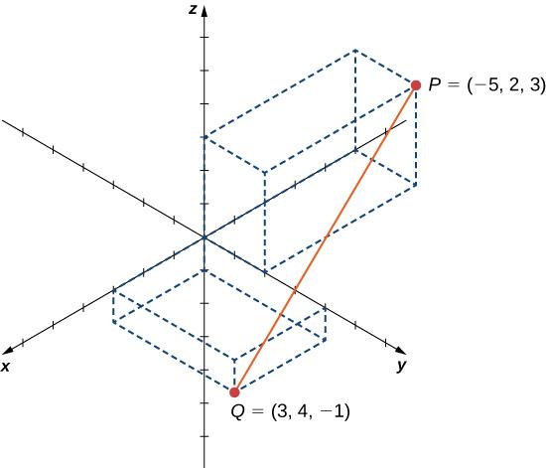
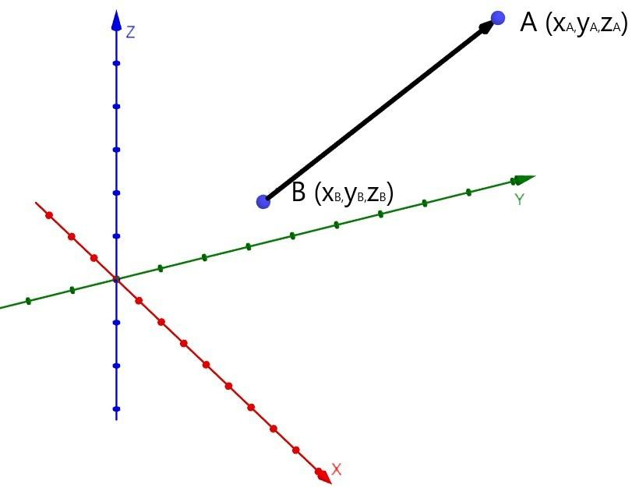

Definition
# Source: AI Source: Provided by: [Data Path: Persons Table -> ID Column: 1, Name_En Column: Motasem Essam] -> From: [ChatGPT] on [7/25/2026]
A segment joining two points in space is the finite straight portion connecting two distinct points in three-dimensional space. It contains the two endpoints and every point between them.
If the endpoints are $A$ and $B$, the segment is written as $\overline{AB}$.
Unlike an infinite line, which extends indefinitely in both directions, a line segment has a fixed length. It is one of the fundamental building blocks of solid geometry and is used to describe edges, diagonals, and distances between points.

Simple Definition
# Source: AI Source: Provided by: [Data Path: Persons Table -> ID Column: 1, Name_En Column: Motasem Essam] -> From: [ChatGPT] on [7/25/2026]
A segment joining two points in space is the shortest straight path between those two points.
For example, if $A$ and $B$ are two corners of a rectangular box, the straight segment connecting them may represent an edge, a face diagonal, or a space diagonal, depending on their positions.

Key Characteristics
# Source: AI Source: Provided by: [Data Path: Persons Table -> ID Column: 1, Name_En Column: Motasem Essam] -> From: [ChatGPT] on [7/25/2026]
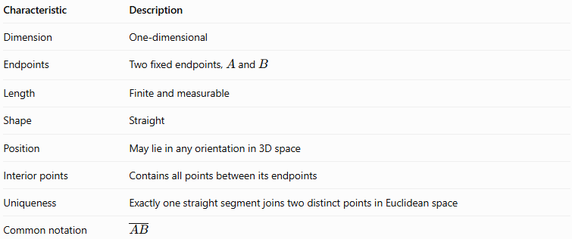
Characteristic | Description
Dimension | One-dimensional
Endpoints | Two fixed endpoints, $A$ and $B$
Length | Finite and measurable
Shape | Straight
Position | May lie in any orientation in 3D space
Interior points | Contains all points between its endpoints
Uniqueness | Exactly one straight segment joins two distinct points in Euclidean space
Common notation | $$\overline{AB}$$

5. Mathematical Representation
# Source: AI Source: Provided by: [Data Path: Persons Table -> ID Column: 1, Name_En Column: Motasem Essam] -> From: [ChatGPT] on [7/25/2026]
Suppose the endpoints are
$$A=\left(x_{1},y_{1},z_{1}\right), B=\left(x_{2},y_{2},z_{2}\right)$$
The segment joining $A$ and $B$ can be represented parametrically as
$$\boxed{r\left(t\right)=A+t\left(B-A\right), 0≤t≤1}$$
In coordinate form,
$$\begin{aligned}x&=x_{1}+t\left(x_{2}-x_{1}\right) \\ y&=y_{1}+t\left(y_{2}-y_{1}\right) \\ z&=z_{1}+t\left(z_{2}-z_{1}\right)\end{aligned}$$
The parameter $t$ determines the position along the segment:
- $t=0$: the point is $A$.
- $t=1$: the point is $B$.
- $0<t<1$: the point lies strictly between $A$ and $B$.
Unlike the equation of an infinite line, the segment restricts $t$ to the interval from 0 to 1.

Length of a Segment Joining Two Points
# Source: AI Source: Provided by: [Data Path: Persons Table -> ID Column: 1, Name_En Column: Motasem Essam] -> From: [ChatGPT] on [7/25/2026]
The length of the segment is the three-dimensional distance between its endpoints.
$$\boxed{AB=\sqrt{{\left(x_{2}-x_{1}\right)}^{2}+{\left(y_{2}-y_{1}\right)}^{2}+{\left(z_{2}-z_{1}\right)}^{2}}}$$
This formula follows from the Pythagorean theorem extended to three dimensions.

Worked Example Example 1: Finding the length
# Source: AI Source: Provided by: [Data Path: Persons Table -> ID Column: 1, Name_En Column: Motasem Essam] -> From: [ChatGPT] on [7/25/2026]
Let
$$A=\left(1,2,3\right), B=\left(4,6,3\right)$$
Substitute the coordinates into the formula:
$$AB=\sqrt{{\left(4-1\right)}^{2}+{\left(6-2\right)}^{2}+{\left(3-3\right)}^{2}}$$
$$=\sqrt{3^{2}+4^{2}+0^{2}}$$
$$=\sqrt{9+16}=\sqrt{25}$$
$$\boxed{AB=5\text{ units}}$$
The segment has a length of 5 units.

Worked Example Example 2: Finding a segment in three dimensions
# Source: AI Source: Provided by: [Data Path: Persons Table -> ID Column: 1, Name_En Column: Motasem Essam] -> From: [ChatGPT] on [7/25/2026]
Let
$$A=\left(2,1,0\right), B=\left(5,5,12\right)$$
Then
$$AB=\sqrt{{\left(5-2\right)}^{2}+{\left(5-1\right)}^{2}+{\left(12-0\right)}^{2}}$$
$$=\sqrt{9+16+144}=\sqrt{169}$$
$$\boxed{AB=13\text{ units}}$$

Midpoint of a Segment in Space
# Source: AI Source: Provided by: [Data Path: Persons Table -> ID Column: 1, Name_En Column: Motasem Essam] -> From: [ChatGPT] on [7/25/2026]
The midpoint is the point exactly halfway between the two endpoints. It divides the segment into two equal parts.
For endpoints $A$ and $B$, the midpoint $M$ is
$$\boxed{M=\left(\frac{x_{1}+x_{2}}{2},\frac{y_{1}+y_{2}}{2},\frac{z_{1}+z_{2}}{2}\right)}$$
Example
For $A=\left(1,2,3\right)$ and $B=\left(5,6,7\right)$,
$$M=\left(\frac{1+5}{2},\frac{2+6}{2},\frac{3+7}{2}\right)$$
Therefore,
$$\boxed{M=\left(3,4,5\right)}$$
The midpoint satisfies $AM=MB$.

Types of Segments Joining Points in a Solid
# Source: AI Source: Provided by: [Data Path: Persons Table -> ID Column: 1, Name_En Column: Motasem Essam] -> From: [ChatGPT] on [7/25/2026]
A segment between two points may have different geometric roles depending on the positions of its endpoints.
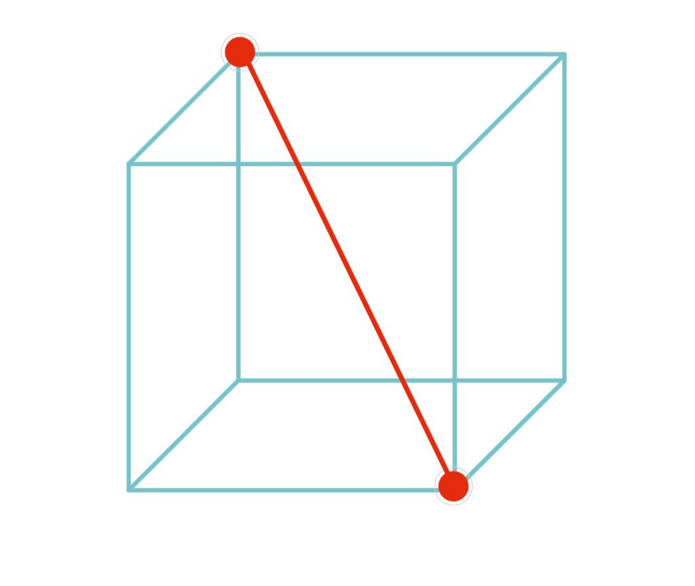

A. Edge segment
# Source: AI Source: Provided by: [Data Path: Persons Table -> ID Column: 1, Name_En Column: Motasem Essam] -> From: [ChatGPT] on [7/25/2026]
Joins two adjacent vertices of a polyhedron and forms part of its boundary.
Example: An edge of a cube with side length $a$ has length $a$.
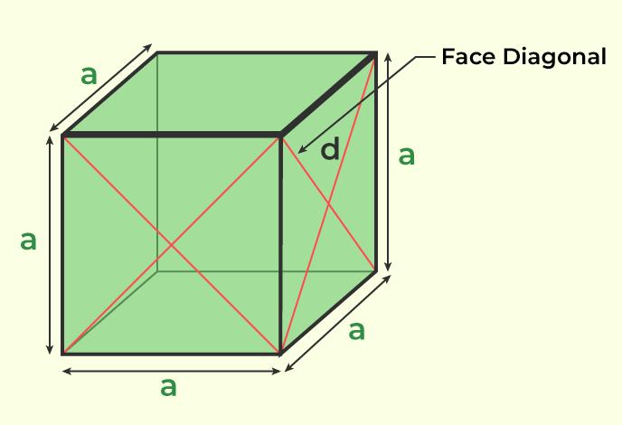

B. Face diagonal segment
# Source: AI Source: Provided by: [Data Path: Persons Table -> ID Column: 1, Name_En Column: Motasem Essam] -> From: [ChatGPT] on [7/25/2026]
Joins two opposite vertices of the same face, passing through the face rather than following its edges.
For a square face of side $a$:
$$d_{f}=a\sqrt{2}$$
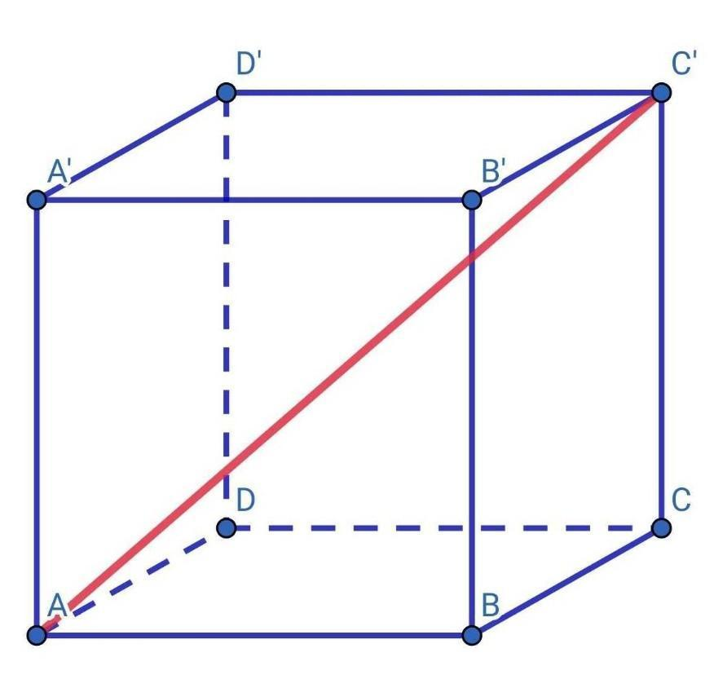

C. Space diagonal segment
# Source: AI Source: Provided by: [Data Path: Persons Table -> ID Column: 1, Name_En Column: Motasem Essam] -> From: [ChatGPT] on [7/25/2026]
Joins two vertices that do not lie on the same face, passing through the interior of the solid.
For a cube of side $a$:
$$d_{s}=a\sqrt{3}$$
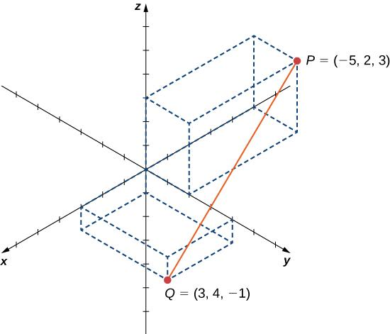

D. General segment between two spatial points
# Source: AI Source: Provided by: [Data Path: Persons Table -> ID Column: 1, Name_En Column: Motasem Essam] -> From: [ChatGPT] on [7/25/2026]
Joins any two distinct points in space, whether or not they are vertices of a solid.
Its length is calculated using the 3D distance formula.

Segment Lengths in a Cuboid
# Source: AI Source: Provided by: [Data Path: Persons Table -> ID Column: 1, Name_En Column: Motasem Essam] -> From: [ChatGPT] on [7/25/2026]
For a rectangular prism with length $l$, width $w$, and height $h$:
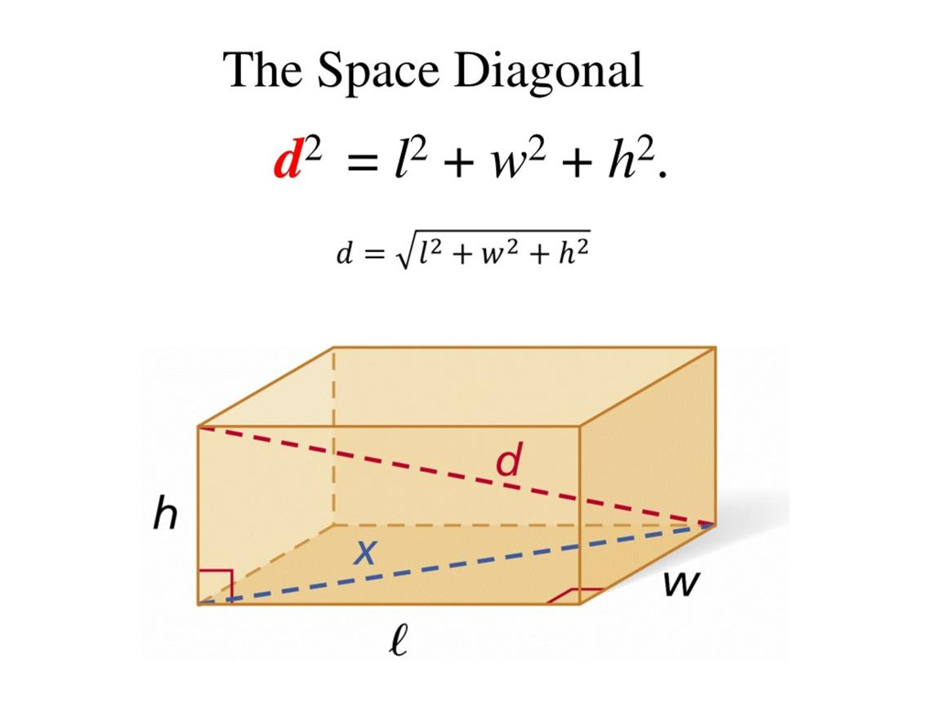
The main segment lengths are:
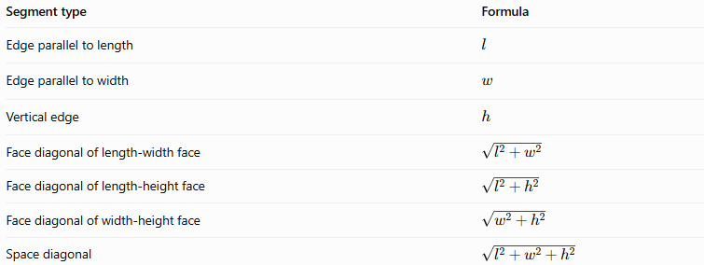
Segment type | Formula
Edge parallel to length | $$l$$
Edge parallel to width | $$w$$
Vertical edge | $$h$$
Face diagonal of length-width face | $$\sqrt{l^{2}+w^{2}}$$
Face diagonal of length-height face | $$\sqrt{l^{2}+h^{2}}$$
Face diagonal of width-height face | $$\sqrt{w^{2}+h^{2}}$$
Space diagonal | $$\sqrt{l^{2}+w^{2}+h^{2}}$$

Worked Example 3: Space diagonal of a cuboid
# Source: AI Source: Provided by: [Data Path: Persons Table -> ID Column: 1, Name_En Column: Motasem Essam] -> From: [ChatGPT] on [7/25/2026]
Suppose a cuboid has
$$l=6, w=4, h=3$$
Its space diagonal is
$$d_{s}=\sqrt{6^{2}+4^{2}+3^{2}}$$
$$=\sqrt{36+16+9}=\sqrt{61}$$
$$\boxed{d_{s}=\sqrt{61}≈7.81\text{ units}}$$

Dividing a Segment in a Given Ratio
# Source: AI Source: Provided by: [Data Path: Persons Table -> ID Column: 1, Name_En Column: Motasem Essam] -> From: [ChatGPT] on [7/25/2026]
A point $P$ can divide the segment from $A$ to $B$ internally in the ratio $m:n$, meaning
$$AP:PB=m:n$$
The coordinates of $P$ are
$$\boxed{P=\left(\frac{nx_{1}+mx_{2}}{m+n},\frac{ny_{1}+my_{2}}{m+n},\frac{nz_{1}+mz_{2}}{m+n}\right)}$$
For example, if $A=\left(0,0,0\right)$, $B=\left(6,9,12\right)$, and $AP:PB=1:2$, then
$$P=\left(\frac{0+6}{3},\frac{0+9}{3},\frac{0+12}{3}\right)$$
$$\boxed{P=\left(2,3,4\right)}$$
This point lies one-third of the way from $A$ to $B$.

Segment vs. Line vs. Ray
# Source: AI Source: Provided by: [Data Path: Persons Table -> ID Column: 1, Name_En Column: Motasem Essam] -> From: [ChatGPT] on [7/25/2026]
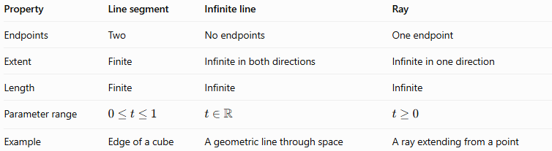
Property | Line segment | Infinite line | Ray
Endpoints | Two | No endpoints | One endpoint
Extent | Finite | Infinite in both directions | Infinite in one direction
Length | Finite | Infinite | Infinite
Parameter range | $$0≤t≤1$$ | $$t∈R$$ | $$t≥0$$
Example | Edge of a cube | A geometric line through space | A ray extending from a point

Applications
# Source: AI Source: Provided by: [Data Path: Persons Table -> ID Column: 1, Name_En Column: Motasem Essam] -> From: [ChatGPT] on [7/25/2026]
Segments joining points in space are used in:
- Geometry: Calculating distances and proving relationships between points.
- Architecture: Measuring straight distances between corners of structures.
- Engineering: Determining component lengths and spatial separations.
- 3D modeling: Connecting vertices to construct edges and polygon meshes.
- Computer graphics: Calculating distances between objects and positions in three-dimensional scenes.
- Navigation and robotics: Measuring straight-line distances between spatial positions.

Key Points
# Source: AI Source: Provided by: [Data Path: Persons Table -> ID Column: 1, Name_En Column: Motasem Essam] -> From: [ChatGPT] on [7/25/2026]
- A segment joining two points is denoted by $\overline{AB}$.
- It is finite and includes both endpoints.
- Exactly one straight segment joins any two distinct points in Euclidean space.
- The 3D distance formula determines its length.
- The midpoint formula identifies the point halfway between its endpoints.
- Edges, face diagonals, and space diagonals are special examples of segments joining points in a solid.
- A segment is distinguished from a line or ray by its finite length and two endpoints.

Conclusion
# Source: AI Source: Provided by: [Data Path: Persons Table -> ID Column: 1, Name_En Column: Motasem Essam] -> From: [ChatGPT] on [7/25/2026]
A segment joining two points in space is a fundamental object in solid geometry. It connects two fixed points by a finite straight path and provides the basis for calculating distances, locating midpoints, describing edges, and determining face and space diagonals. Its coordinate representation makes it possible to analyze spatial relationships precisely.

